1.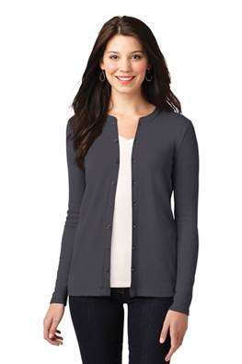

2. 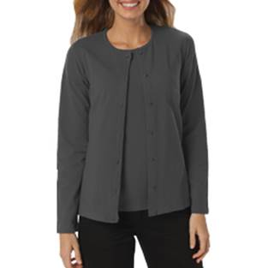

3. 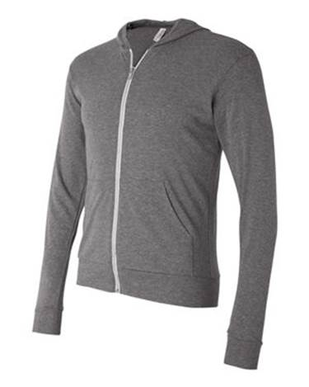

4. 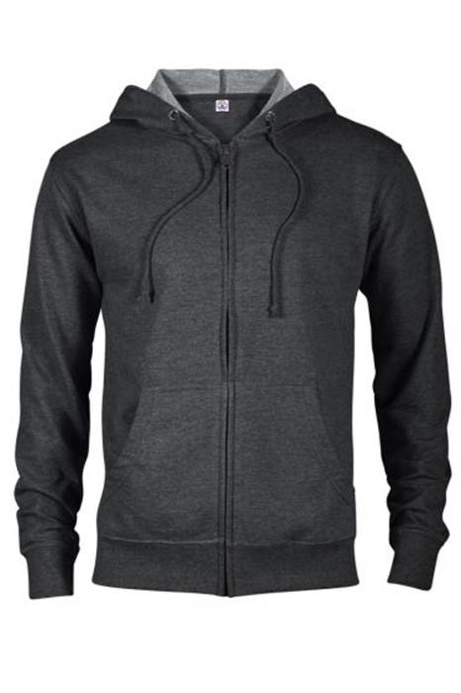

5. 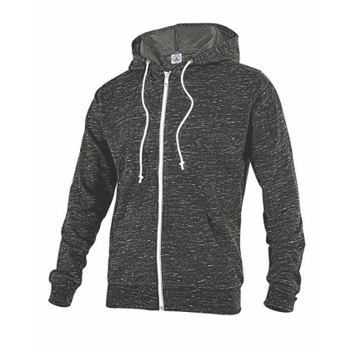

6. 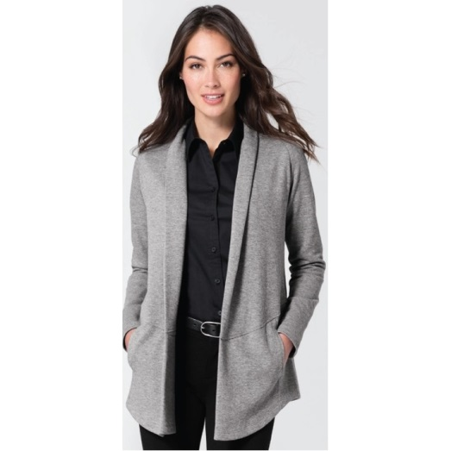

7. 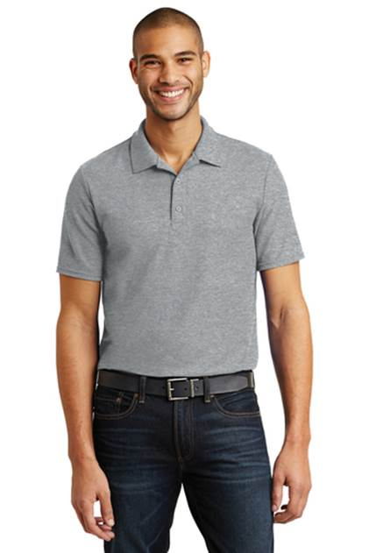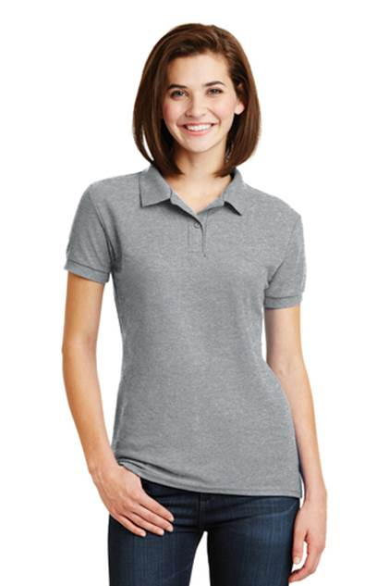

PRICES

|  |  |
| --- | --- |
| 1. Ladies Concept Stretch Button-Front Cardigan | $          35.00 |
|  |  |
| 1. Ladies Long Sleeve Button Front Cardigan Sweater | $          32.00 |
|  |  |
| 1. Bella + Canvas® Unisex Lightweight Hooded Full-Zip Sweater (XS-XL) | $          39.00 |
|  |  |
| 1. Delta Fleece Unisex Adult French Terry Zip Front Hoodie | $          31.00 |
|  |  |
| 1. Delta Fleece Unisex Snow Heather French Terry Zip Hoodie | $          31.00 |
|  |  |
| 1. Ladies InterLock Cardigan | $          38.00 |
|  |  |
| 1. Short Sleeve Polo (men and women) | $ 25.00 |